Learning Targets, Formative Assessment, Retakes….steps to get started!
1. Write learning targets that are aligned with essential standards.
2. Develop each unit with learning targets and assessment question(s) for each target that will be used to check mastery of learning targets. Determine what mastery looks like for each target.
3. Post targets in your classroom where the students are primarily focused throughout the period. Provide learning targets (hard copy) for all students at the beginning of each unit.
4. Start referring to your targets throughout your instruction (beginning, middle, and end). Reference learning targets on all homework assignments and assessments.
5. Start allowing retakes. However, before you allow students to retake assessments determine the following:
What will students have to do for you before they can retake a test (probably needs to be more than just make test corrections)? What will students get to do if they achieve mastery the first time around? What will you do if there is a student that has to take the test more than twice?
6. Once you decide to start retakes, you need to figure out the best way to set up your grade book by learning targets so you can get some good data.
7. Start creating common formative assessments with your team. Compare results and reflect on how you can reteach those students who are still struggling.
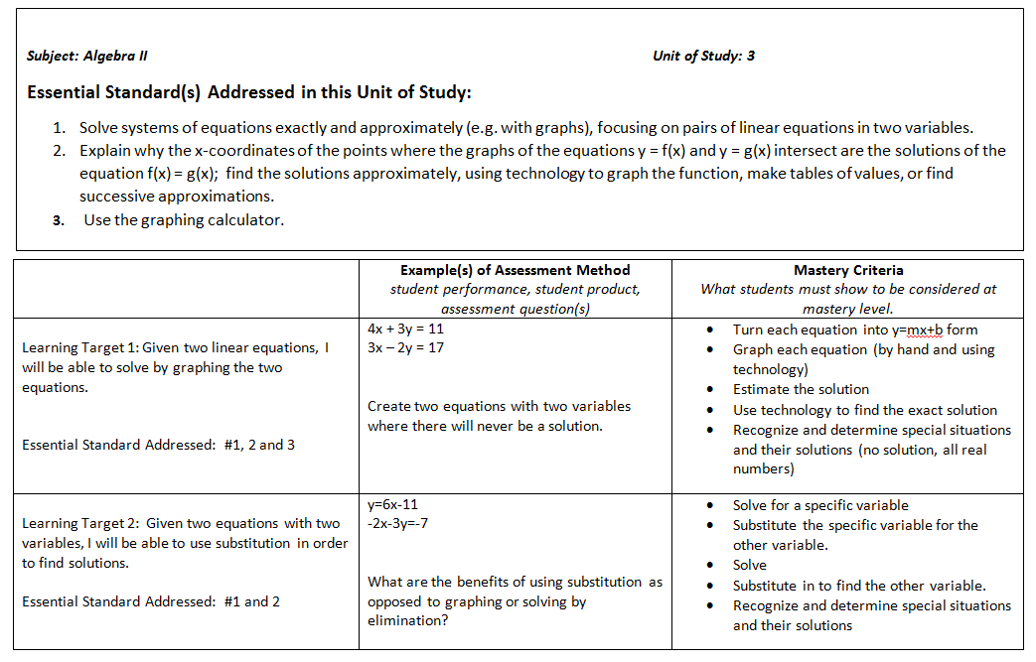
Example of a Unit Breakdown
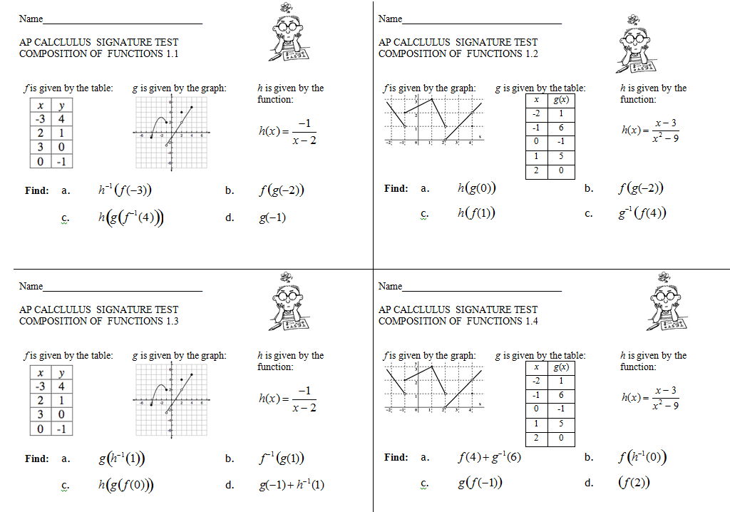
Example of Assessment and Retakes
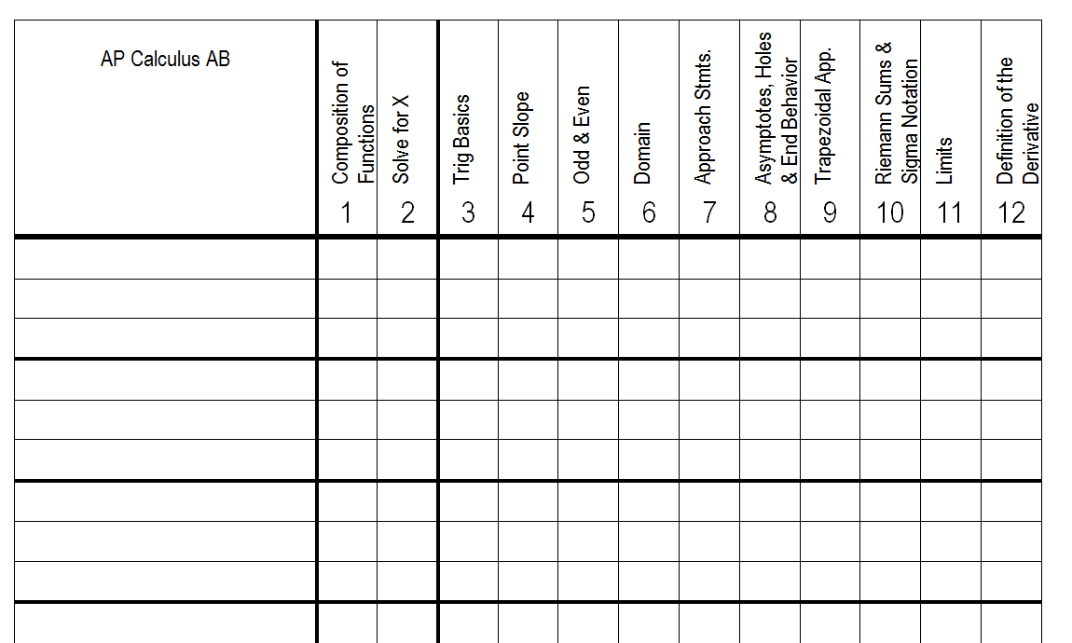
Example of Grades/Gradebooks

