**Another Approach to ¼**

Comment on whether a solution is correct or not. Explain your reasoning.*

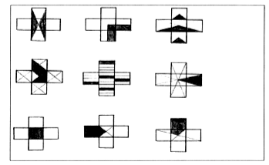

*Dekker,T. & Querelle, N. (2002). Great assessment problems *(and how to solve them).* CATCH project [www.fi.uu.nl/catch](http://www.fi.uu.nl/catch)