Another Approach to ¼

Comment on whether a solution is correct or not. Explain your reasoning.*

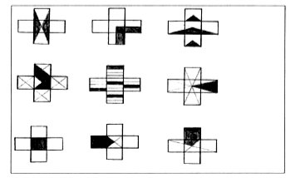

*Dekker,T. & Querelle, N. (2002). Great assessment problems (and how to solve them). CATCH project www.fi.uu.nl/catch

