Inquiry as a Path to Thinking Classrooms Week 1 July 2017
PCMI Reflecting on Practice

Unit 1 Tasks
Day 1 – The role of tasks in making student thinking visible & what makes a worthwhile task?
“Central to the concept of inquiry learning is the notion of a mathematical community. Students are expected to participate in discussion, promote and defend mathematical ideas, solve unfamiliar problems, and challenge the ideas of their peers.”
Goos, M. (2004). Learning mathematics in a classroom community of inquiry. Journal
for Research in Mathematics Education, 35(4), 258-291.

Protocol at Whiteboard
- All work must be done on board
- Only one dry erase marker per group
- One person will start with the marker, but the marker can be passed
- The person with the marker cannot talk but should record ideas from the other group members

1001 Pennies Task
There are 1001 pennies lined up on a table. I come along and replace every second coin with a nickel. Then I replace every third coin with a dime. Finally, I replace every fourth coin with a quarter. How much money is on the table?

Round Robin Protocol
Everyone at the table should make a short statement or comment related to the question or discussion; going around in consecutive order with no input or discussion from others until everyone has had a turn.

Circle-Square Task
The sides of the square are 20. What is the diameter of the circle?
Geometry Problem from Using Technology to Promote Productive Struggle; presentation by Jill Gough and Jennifer Wilson
https://docs.google.com/presentation/d/1cEvXJ5X42jXHqPimcp_pc-A4hvC65vicQUpbhdJFmzY/edit#slide=id.g1eebe5b993_0_11
(or google: promote productive struggle jill gough)

PollEV.com

Unit 1 Tasks
Day 2 – Cognitive demand in a worthwhile task

“Proper inquiry instruction requires facilitation by the instructor and well-designed inquiry tasks. Such tasks can be identified as problematic situations that engage the students in mathematical problems in context.”
Hodge, L. (2008). Student roles and mathematical competence in two contrasting
elementary classes. Mathematics Education Research Journal, 20 (1), 32-50.

Farmer Jack Task
Farmer Jack harvested 30,000 bushels of corn over a ten-year period. He wanted to make a table showing that he was a good farmer and that his harvest had increased by the same amount each year. Create Farmer Jack’s table for the ten-year period.

Worthwhile Tasks Wordle
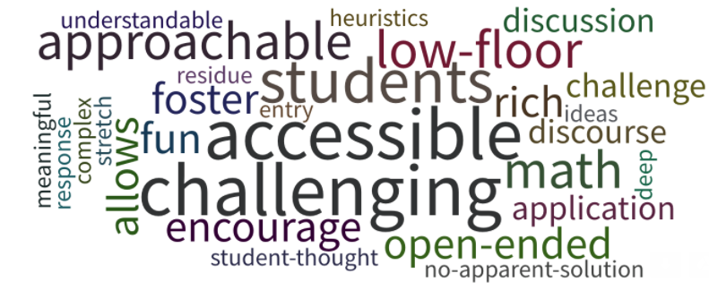

Higher-level demands (Doing Mathematics)
  - Require complex and nonalgorithmic thinking—a predictable, well-rehearsed approach or pathway is not explicitly suggested by the task, task instructions, or a worked-out example.
  - Require students to explore and understand the nature of mathematical concepts, processes, or relationships.
  - Demand self-monitoring or self-regulation of one’s own cognitive processes.
  - Require students to access relevant knowledge and experiences and make appropriate use of them in working through the task.
  - Require students to analyze the task and actively examine task constraints that may limit possible solution strategies and solutions.
  - Require considerable cognitive effort and may involve some level of anxiety for the student because of the unpredictable nature of the solution process required.
Stein, M. K., & Smith, M. S. (1998). Mathematical tasks as a framework for reflection. Mathematics Teaching in the Middle School, 3, 268-275.
National Council of Teachers of Mathematics. (2014). Principles to actions: Ensuring mathematical success for all. Reston, VA: Author. p. 18.
Effective mathematics teaching uses tasks as one way to motivate student learning and help students build new mathematical knowledge through problems solving. Research on the use of mathematical tasks over the last two decades has yielded three major findings:
- Not all tasks provide the same opportunities for student thinking and learning.
(Hiebert et al., 1997; Stein et al., 2009)
- Student learning is greatest in classrooms where the tasks consistently encourage high-level student thinking and reasoning and least in classrooms where the tasks are routinely procedural in nature. (Boaler & Staples, 2008; Hiebert & Wearne, 1993; Stein & Lane, 1996)
- Tasks with high cognitive demands are the most difficult to implement well and are often transformed into less demanding tasks during instruction. (Stein, Grover, & Henningsen, 1996; Stigler & Hiebert, 2004)
To ensure that students have the opportunity to engage in high-level thinking, teachers must regularly select and implement tasks that promote reasoning and problem solving.
National Council of Teachers of Mathematics. (2014). Principles to actions: Ensuring mathematical success for all. Reston, VA: Author. p. 17.
Quoted References
Boaler, J., & Staples, M. (2008). Creating mathematical futures through an equitable teaching approach: The case of Railside School. The Teachers College Record, 110(3), 608–645.
Hiebert, J., Carpenter, T. P., Fennema, E., Fuson, K. C., Wearne, D., Murray, H., et al. (1997). Making sense: Teaching and learning mathematics with understanding. Portsmouth, NH: Heinemann.
Hiebert, J., & Wearne, D. (1993). Instructional tasks, classroom discourse, and students’ learning in second-grade arithmetic. American Educational Research Journal, 30(2), 393–425.
Stein, M. K., Smith, M. S., Henningsen, M. A., & Silver, E. A. (2009). Implementing standards-based mathematics instruction: A casebook for professional development (Second Edition). New York, NY: Teachers College Press.
Stein, M. K., & Lane, S. (1996). Instructional tasks and the development of student capacity to think and reason: An analysis of the relationship between teaching and learning in a reform mathematics project. Educational Research and Evaluation, 2(1), 50-80.
Stein, M., Grover, & Henningsen, M. (1996). Building student capacity for mathematical thinking and reasoning: An analysis of mathematical tasks in reform classrooms. American Educational Research Journal, 33, 455-488
Stigler, J. W., & Hiebert, J. (2004). Improving mathematics teaching. Educational Leadership, 61(5), 12–16.

No More Cookbook Lessons Article
Harper, S. R., & Edwards, M. T. (2011). A new recipe: No more cookbook lessons. Mathematics Teacher, 105(3), 180-188. Reston VA: National Council of Teachers of Mathematics
http://www.jstor.org/stable/10.5951/mathteacher.105.3.0180

Unit 1 Tasks
Day 3 – Barriers to implementing worthwhile tasks such as over scaffolding and low cognitive demand, and strategies for adapting a task to make a task worthwhile

“Providing students with opportunities to actively engage with content during their classes leads to positive learning outcomes.”
Braun, B. (2015, September 10). Active learning in mathematics, Part I: The challenge of defining active learning. Retrieved July 2, 2017, from http://blogs.ams.org/matheducation /2015/09/10/active-learning-in-mathematics-part-i-the-challenge-of-defining-active-learning/

Video Norms Protocol
- Video clips are to spur discussion, not criticism
- Video clips are to spur inquiry, not judgement
- Video clips are to provide a snapshot of a particular moment
- Be sure to cite specific examples (evidence) from the clip

Keychain Video
Solving Equations, (2005). Break Through Mathematics. Lesson Lab. Pearson Education Company.

Systems: Two Versions of the Same Task
Adapted from: Herbel-Eisenmann, B. & Crillio, M. (2013). Two versions of same task adapted from Association of Mathematics Teacher Educators presentation, Mathematics discourse in secondary classrooms: A case-based professional development curriculum. Orlando FL

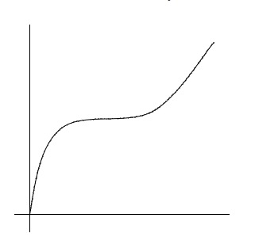

A Story About Change Task
Create a situation where the change in one variable would produce
the change in the other as represented in the graph.
Modeling Change. (2004) PCMI Teacher Program Lesson Study

Open-ended Questions Article
Sanchez, W. B. (2013). Open-ended questions and the process standards. Mathematics Teacher, 107(3), 206–211.

Unit 1 Tasks
Day 4 – Thinking classrooms & strategies to adapt and modify tasks

“Inquiry-Based Learning (IBL) is an approach to teaching and learning in which the classroom environment is characterized by the student being the active participant while the teacher’s role is decentralized. This pedagogy builds on guided discovery, a descendant of the ancient Socratic approach to teaching.”
Young, J. W. A. (1906). The Teaching of Mathematics in the Elementary and Secondary School. Longmans, Green, and Co., 1906.

Worthwhile Tasks in a Thinking Classroom
- Engage each student through an appropriate level of cognitive demand
- Promote discussion to make student thinking visible
- Relate to an important mathematical goal

Asking a Question Task
Original task: Solve 2x²+5x=3
Modified task: Explain how you can tell whether the equation 2x²+5x=3 has a solution.

Tasks to Modify
- A flowerpot is cylindrical. The radius of the base is 14 cm. The height is 25 cm. What is the volume of the flowerpot?
- c is a zero of the polynomial. Find the rest of the real zeros and factor the polynomial
x³ +2x² −3x−6, c=−2
- Solve the formula C= (5/9)(F-32) for F

Gallery Walk Protocol
Move to the next presentation to your right when you are facing the workspace.
Write comments related to your observations on post-it notes and attach to the presentation.
Repeat until you return to your own presentation. Consider the comments.

A Thinking Classroom Quote
“As mentioned, a thinking classroom is a classroom that is not only conducive to thinking but also occasions thinking, a space that is inhabited by thinking individuals as well as individuals thinking collectively, learning together, and constructing knowledge and understanding through activity and discussion. It is a space wherein the teacher not only fosters thinking but also expects it, both implicitly and explicitly.”
Liljedahl, P. (in press). Building thinking classrooms: Conditions for problem solving. In P. Felmer, J. Kilpatrick, & E. Pekhonen (Eds.) Posing and Solving Mathematical Problems: Advances and New Perspectives. New York, NY: Springer. p. 5

Active Learning Increases Student Performance Article
Freeman, S., Eddy, S. L., McDonough, M., Smith, M. K., Okoroafor, N., Jordt, H., & Wenderoth, M. P. (2014). Active learning increases student performance in science, engineering, and mathematics. Proceedings of the National Academy of Sciences of the United States of America, 111(23), 8410–8415

